**University of the Cordilleras**

**College of Information Technology and Computer Science**

CC12 – Statistical Design and Analysis

**Colab LabAct2: Significance Test on Proportions**

Problem 1:

In a sample of 100 M&M's 8 of them were brown. Test the claim of the Mars candy company that the percentage of brown M&M's is equal to 13%. Will the conclusion change if the confidence level used is 85%?

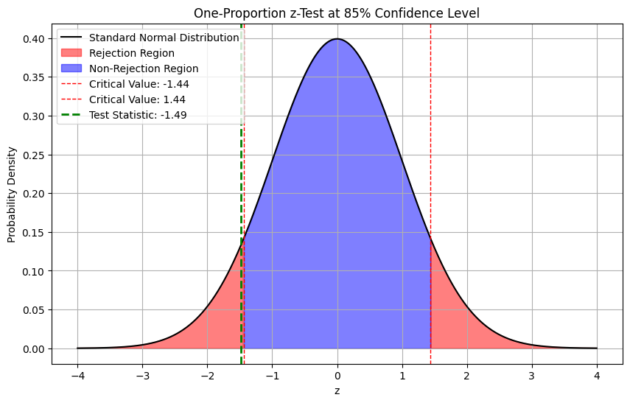**Curve**

**Conclusion**

The test statistic 1.49 is greater than the critical value ±1.44, therefore we reject the null hypothesis at the 85% confidence level, concluding that the percentage of brown M&M's is different from 13%.

Problem 2:

An apple farmer has in the past lost an average of 3% of his trees each year. He notices that he has been losing more trees lately. In a sample of 200 trees, 11 have died.  Test the claim that his loss rate is greater than 3%, perhaps due to some new environmental factor. Use 95% confidence level.

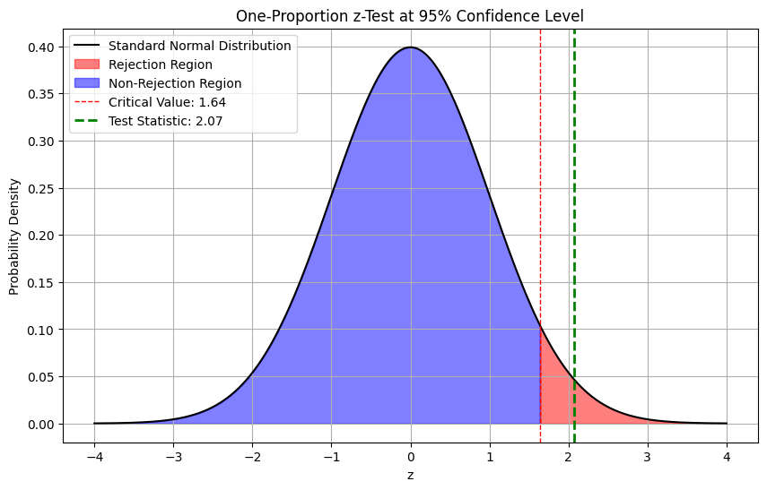**Curve**

**Conclusion**

At the 95% confidence level, the test statistic is approximately 2.08 is higher than the critical value of 1.645. Therefore, we reject the null hypothesis and conclude that there is significant evidence to suggest that the apple farmer's tree loss rate is greater than 3%.